ArxDbg
Jim Awe
1/27/99

ArxDbg is a program designed to accomplish several tasks:

- Test as many areas of ARX as possible
- Serve as a learning/debugging tool by allowing the user to monitor what types of events are happening in the system.
- Provide a framework for quick tests of concepts without having to create “scaffolding” just to get the test up and running.
- Provide a grab bag of source code and re-usable utility classes for 3rdParty developers to help them with common tasks not supported by ARX directly.
- Introduce 2 custom entities with some of the common characteristics of AEC entities (Architectural Desktop) so that we can test them with a “raw” connection to ARX.

To access the commands in ArxDbg, use the right-click application menu:

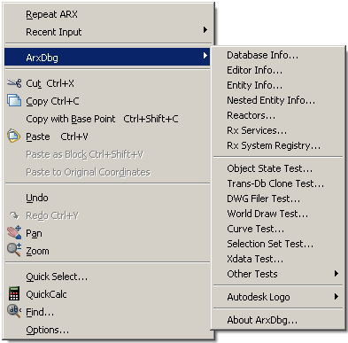

Each of the commands is explained in more detail below:

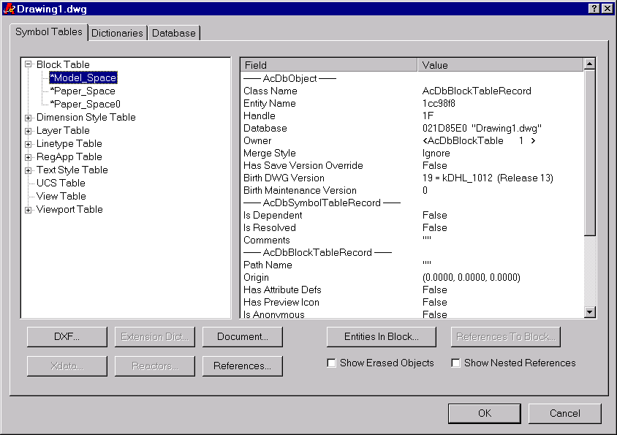
MENU: Database Info…
CMDLINE: SnoopDatabase

This command lets you look at all the information available from a given database. For all objects, as much information as possible is shown in the panel at the right. Other information common to all objects is accessible by clicking on one of the other buttons. For AcDbBlockTableRecords, additional buttons become available to allow for browsing the entities within the block, or for showing the references to that block definition.

Navigating to different dialogs through these buttons can sometimes get circular. For instance, you could hit the “Document” button to take you to a page listing the AcApDocuments currently in this session. That page has a “Database…” button that would call up this dialog again. It is up to the user not to stack up a thousand copies of the same dialog on top of each other.

All “Snooping” dialogs, like the one listed above, also allow you to right-click on the gray frame part of each page. By doing so, you can add the current object to a “Clone Set” that can be used by other dialogs, such as the test for Trans-Database cloning. This is an easy way to select objects that are non-graphical. See “Trans-Database Cloning Tests” for more details.

The various sub-dialogs are listed below:

DXF: show a dialog listing what a call to ads_entget() would dump out.
Xdata: show all the Extended Entity Data for the selected object, separated by registered
application.
Extension Dict: show the extension dictionary for a given object.
Reactors: show the persistent and transient reactors for a given object.
Document: forward to the “Editor” property sheet and show the Documents snoop page so you can
see the document that goes with this database.
References: show all references that this object has to other objects. The references are divided into
the four types (HardPointerId, SoftPointerId, HardOwnerId, and SoftOwnerId).
Object Id Info: By right-clicking on the gray area of the dialog, you can also see detailed info on the objectId of an object.

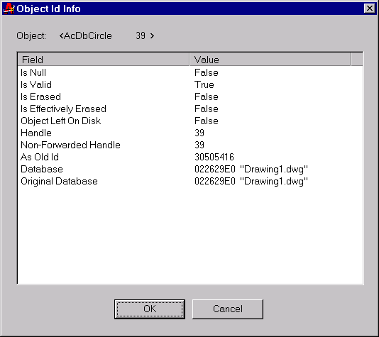
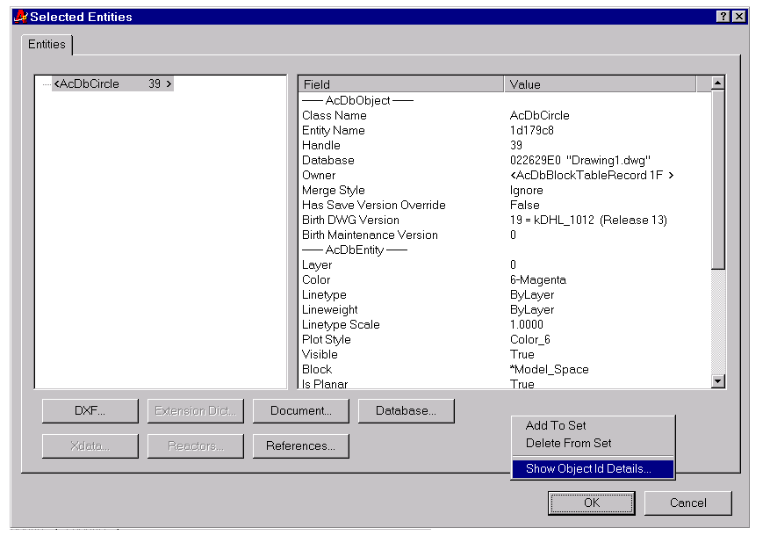
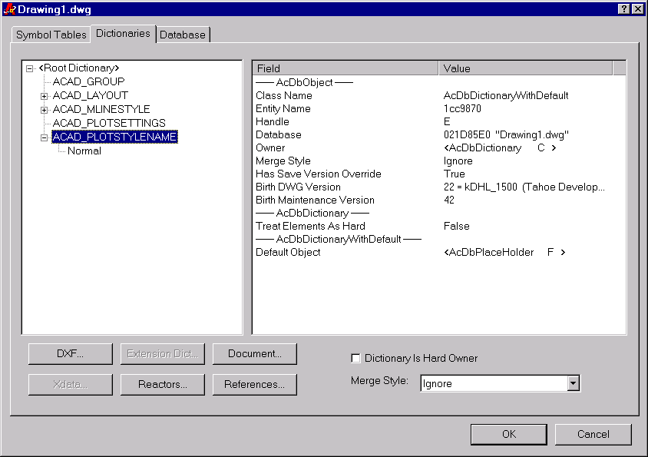

The “Dictionaries” page shows the Named Object Dictionary, and all of its sub-dictionaries. Extra controls on this page include:

Dictionary Is Hard Owner: this maps to the call AcDbDictionary::setTreatElementsAsHard(). Toggling this will actually change the setting in the dictionary.

Merge Style: this maps to the call AcDbDictionary::setMergeStyle().

Dictionaries and Dictionary Records can be renamed by doing in-place editing on the TreeCtrl itself.

Dictionaries and Dictionary Records can be deleted/removed by using the “Delete” key.

NOTE: there is no guarantee as to what will happen when you rename or delete a dictionary. For things like MlineStyles, it is fatal to AutoCAD. You can use this test to make sure that your objects can exist under duress.

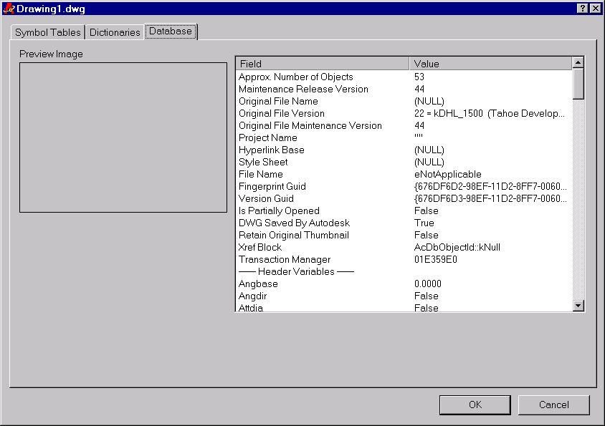

This page shows the misc. information available from an AcDbDatabase pointer. It also will show the Thumbnail preview image, when available.

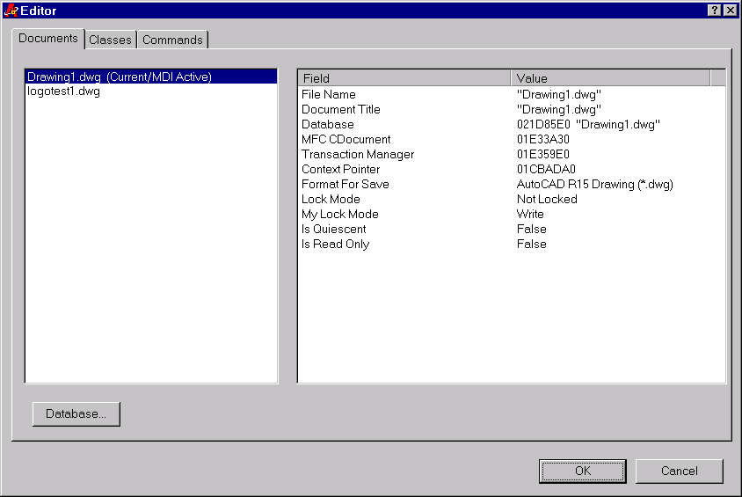
MENU: Editor Info…
CMDLINE: SnoopEditor

This command allows you to look at all the information associated with the current editor. For each document, you can browse its associated database, which will take you to the same Dialog used for “SnoopDatabase”.

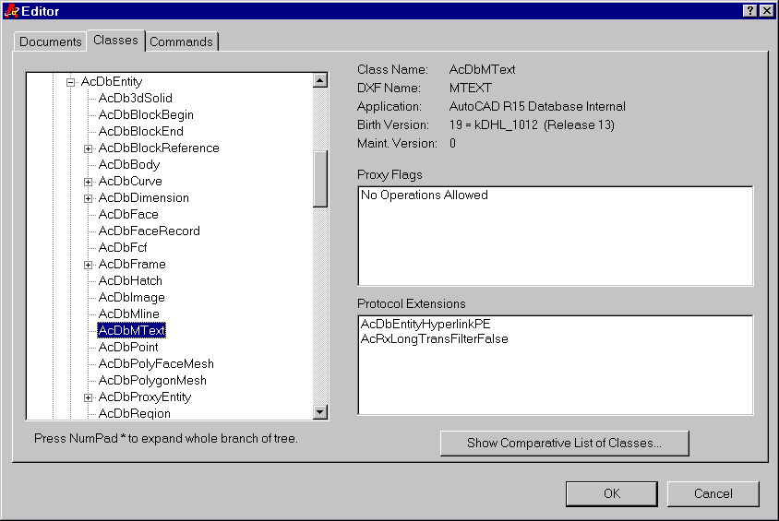
This Dialog shows the entire registered ARX class hierarchy. Information for each class is listed in the pane at the right. The “Show Comparative List of Classes” button brings up a different dialog listing all the classes side-by-side, so that you can compare the settings of things like “Class Name”, “Application Name”, “Proxy Flags”, etc. Doing so helps ensure that your classes have consistent naming and settings.

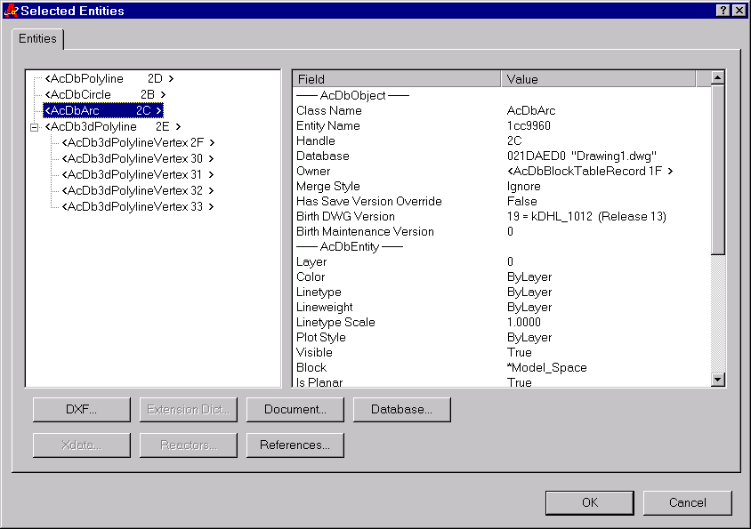
MENU: “Entity Info”
CMDLINE: “SnoopEntities”

MENU: “Nested Entity Info”
CMDLINE: “SnoopEntitiesNested”

Both of these commands allow you to view the data associated with a given set of entities. The “Nested” version will use acedNEntSelP() to pick entities nested inside blocks or Xrefs. For complex entities like AcDbBlockReference and AcDb2dPolyline, you can expand the branch of the tree to get at the sub-entities.

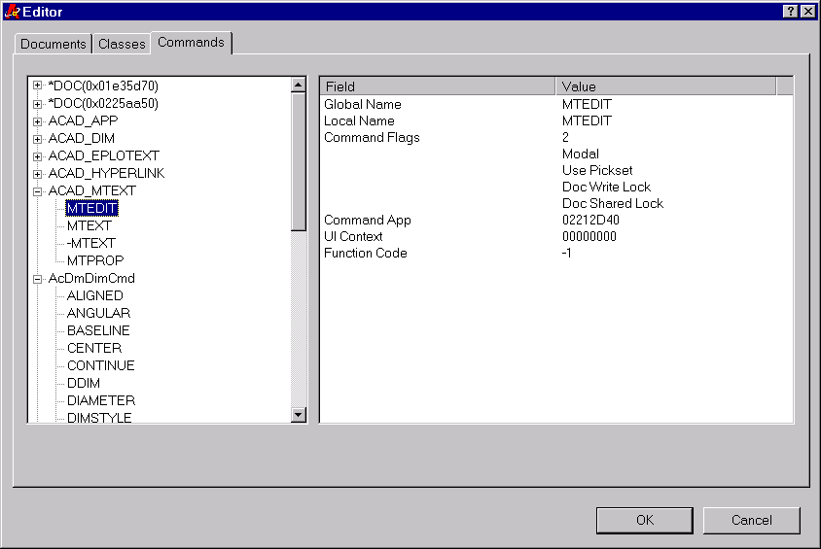

This Dialog lists all the registered commands. The commands are grouped by the “Group Name” used when registering them. This dialog is also a good check to see if the commands for a given application are registered consistently.

NOTE: I would like to add an “Applications” page to this dialog, but there is no good map between “app name” and “app pointer”. I can usually get one or the other, but no map between them.

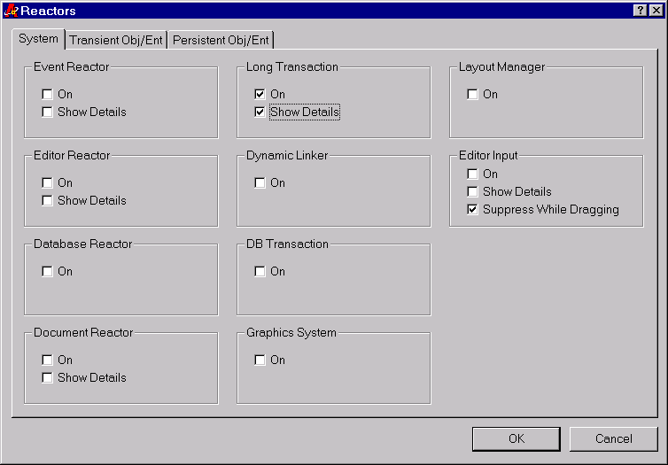
This Dialog allows you to turn on a print-only version of the various “system” reactors available in ARX. When the reactors receive notification, they print out the message and some basic information. If the “Show Details” checkbox is also on, then more detailed information will be displayed. For example, when doing a Long Transaction during RefEdit, the Show Details checkbox will cause the reactor to stop and show a dialog with the state of the AcDbIdMapping at each stage of the Check-out/Check-in process.

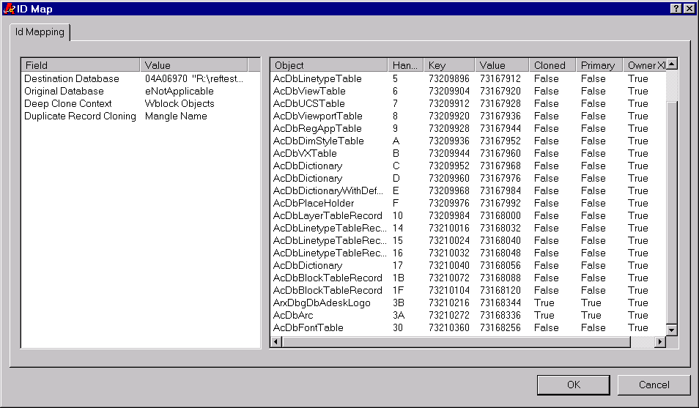

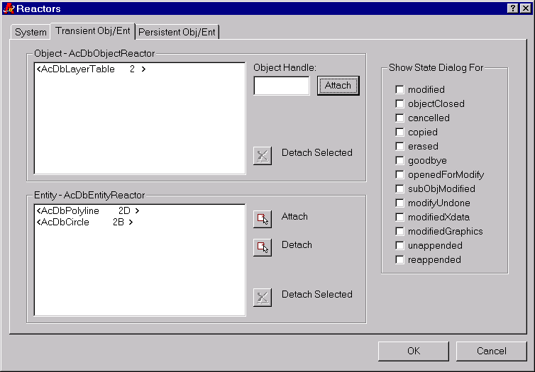

These two dialogs (the persistent dialog is not shown, but looks exactly the same) allow you to attach sample Transient and Persistent reactors to various objects and entities. It serves as a basic spy to print out the notification messages, and as sample code for 3rdParty developers. The check boxes at the right will cause the “State” dialog to be shown. This is useful for finding out what state the object is in when you get notification, and whether you are allowed to open it or modify it in any way. See “ObjectStateTest” for more details.

NOTE: when the state dialog comes up in this context, there is no attempt made to safe-guard against unbalanced calls (as is done when this dialog is used in other contexts). Therefore, if you don’t balance calls to open and close (and leave it in its original state), it will crash AutoCAD.

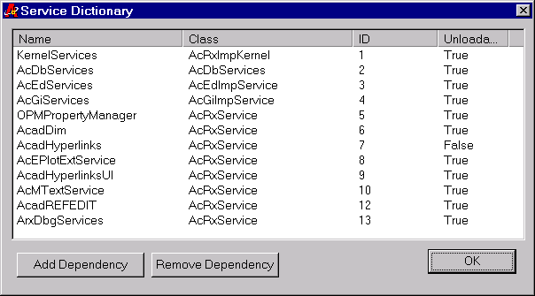
MENU: “Rx Services”
CMDLINE: “SnoopServices”

This command just lets you see the currently registered services in the service dictionary. You can add and remove dependencies at your own risk.

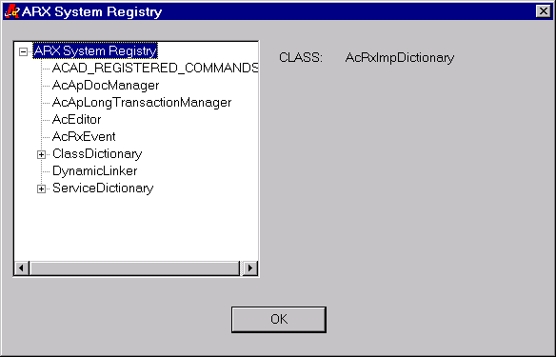

MENU: “Rx System Registry”
CMDLINE: “SnoopSysRegistry”

This command shows the contents of the System Registry. Not very exciting.

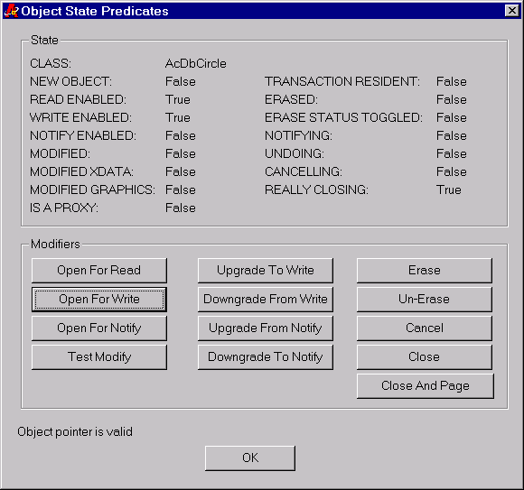
MENU: “Object State Test”
CMDLINE: “TestState”

This command is used to test all the state flags of a given object. It is safe-guarded so that if you quit the dialog with the object still open, it will close it all the way out. The “Test Modify” button increments the value of the entities color index so that the effects of “Close” vs. “Cancel” can be seen.

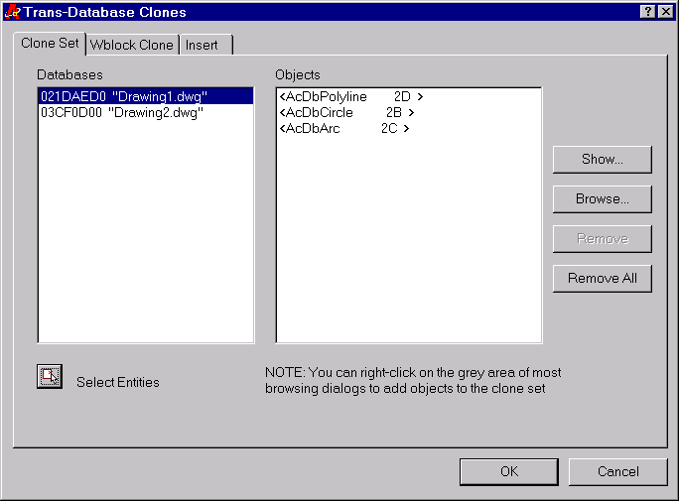
MENU: “Trans-Db Clone Test”
CMDLINE: “TestTransDbClones”

This command is used to test all the various forms of Wblock, Insert, and eventually WblockCloneObjects. The first page is used to build a “Clone Set” of objects that will be cloned via the “Wblock Clone” page, or via the “Wblock Clone Objects” page (when finished). You can select entities from the screen by using the “pick” button, or you can use the “Browse” button to find non-graphical objects to include in the clone set. A different clone set is kept for each active database and they are automatically deleted when a database sends out “aboutToBeDestroyed” notification.

Build the Clone Set up on this page, and then use the following two pages to actually do something with the clone set.

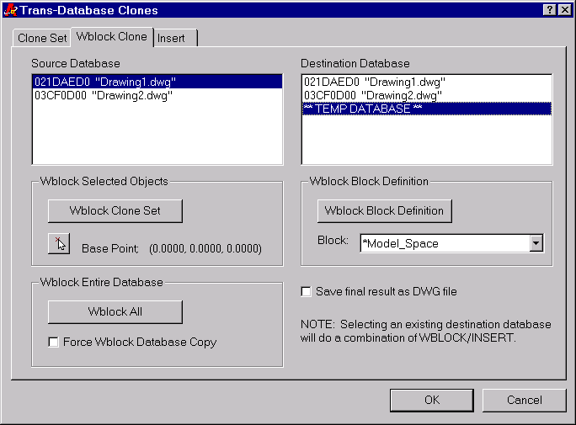

This Dialog exercises the 3 forms of AcDbDatabase::wblock(). “Wblock Clone Set” will use the Clone Set defined for the selected source database. When the wblock process is complete, it will bring up the “Snoop Database” Dialog and allow you to look at the state of the final database. You can also choose to save that database to a file so you can later open it up and test the validity of the resulting drawing.

If you choose to clone to a non-temporary database, then it will actually do a WBLOCK/INSERT combination since the wblock() function creates a new AcDbDatabase and there would otherwise be no way to get the objects to the existing database.

All buttons will become disabled if the source and destination databases are the same.

NOTE: In the future I will add a page for the AcDbDatabase::wblockCloneObjects() and AcDbLongTransactions. Then all trans-db cloning processes will be accounted for.

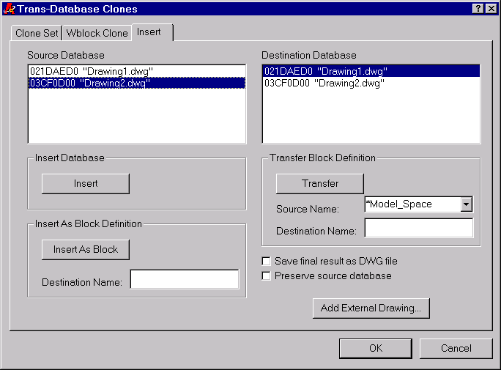

This Dialog exercises the 3 forms of AcDbDatabase::insert(). It is very similar to the “Wblock Clone” page.

The Source and Destination Database lists show only the active databases by default. Choose the “Add External Drawing” button to select external databases on disk.

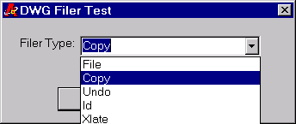
MENU: “DWG Filer Test”
CMDLINE: “TestDwgFiler”

This command has a derived AcDbDwgFiler that simply prints out all the calls and all the data that an object makes for a given type of filer. All output is directed to the Text Window.

NOTE: An AcDb::kFileFiler is mapped to an AcDb::kCopyFiler because internal AutoCAD code blindly casts the filer pointer to an internal derived class, which will, of course, crash AutoCAD.
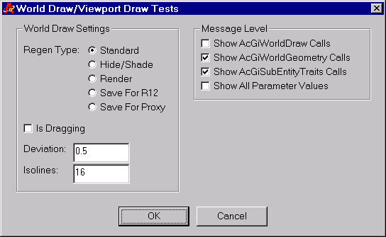

MENU: “World Draw Test”
CMDLINE: “TestWorldDraw”

This command has a derived AcGiWorldDraw and related classes that simply print out all the calls made to AcGi. You can choose various levels of details for the messaging that comes out.

NOTE: This command has not had much updating for Tahoe, and needs to have its corresponding ViewportDraw derived classes updated. It will be finished at a later date. If the object you are testing against uses viewportDraw(), nothing will be printed out.

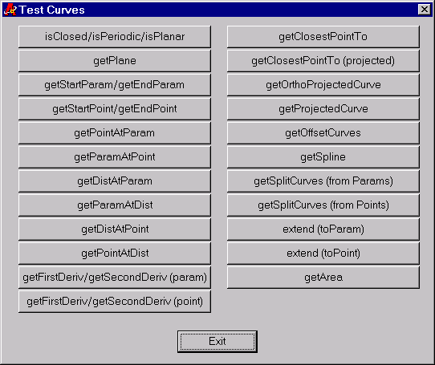

MENU: “Test Curves”
CMDLINE: “TestCurve”

This command calls all the curve protocol on any AcDbCurve derived object and prints out the resultant information. In many cases, it will add “reference” entities to the drawing so you can see what kind of information it returned. For instance, in the case of points, it will turn PDMODE to 99 and place a point at the spot where the curve function answered the question. For derivatives, it adds AcDbRays to the drawing, (color 1 = first derivative, color 2 = second derivative). This is a good test to make sure that curve entities correctly answer all the necessary curve protocol.

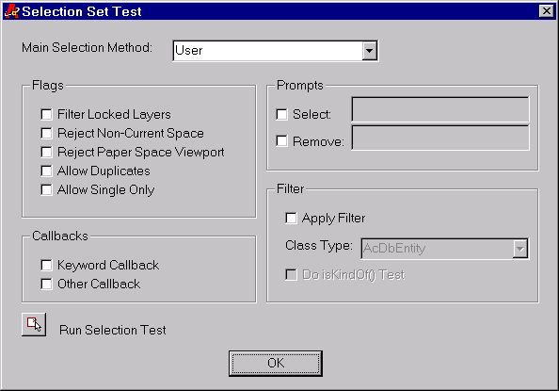

MENU: “Selection Set Test”
CMDLINE: “TestSelSet”

This command tests and provides sample code for all of the various options concerning selection sets. It uses the class “ArxDbgSelSet” which is a copy of the AEC class “AecAcadSelSet”. This class is provided as an example for 3rdParty developers who want a more elegant way to deal with all the low-level details of legacy selection sets. It also shows an example for how to filter on the selection set by class type, using either isA() or isKindOf() tests.

MENU: “Xdata Test”
CMDLINE: “TestXdata”

This command tests and provides sample code for managing and retrieving Xdata from a given object. It uses the class ArxDbgAppXdata (and related classes) which are copies of the original AEC classes.

This command is also useful when you just want to quickly see what happens to Xdata during some other operation such as BREAK, TRIM, EXPLODE, etc. You don’t have to go searching for an entity that happens to use Xdata.

MENU: “Extents”
CMDLINE: “TestExtents”

Calls the AcDbEntity::getGeomExtents() function and builds a box around the extents so that you can examine them graphically.

MENU: “Intersect With”
CMDLINE: “TestIntersect”

Calls the AcDbEntity::intersectWith() function in all of its forms and adds AcDbPoint entities to the reported intersection locations.

MENU: “Grip Points”
CMDLINE: “TestGetGripPoints”

Calls the AcDbEntity::getGripPoints() function and adds AcDbPoint entities to the reported locations.

MENU: “Stretch Points”
CMDLINE: “TestGetStretchPoints”

Calls the AcDbEntity::getStretchPoints() function and adds AcDbPoint entities to the reported locations.

MENU: “OSNAP”
CMDLINE: “TestGetOsnapPoints”

Calls the AcDbEntity::getOsnapPoints() function and adds AcDbPoint entities to the reported locations.

MENU: “Extension DictionaryAdd”
CMDLINE: “TestExtDictAdd”

Adds an AcDbXRecord with arbitrary values to the extension dictionary of an object. Used mainly as a quick test of what happens to an extension dictionary during certain operations.

MENU: “Extension Dictionary Remove”
CMDLINE: “TestExtDictRemove”

Tries to remove an empty extension dictionary from the given object. If you need to empty it first, use the “SnoopEntites” command to get to the dictionary, and remove all the entries by using the Delete key.

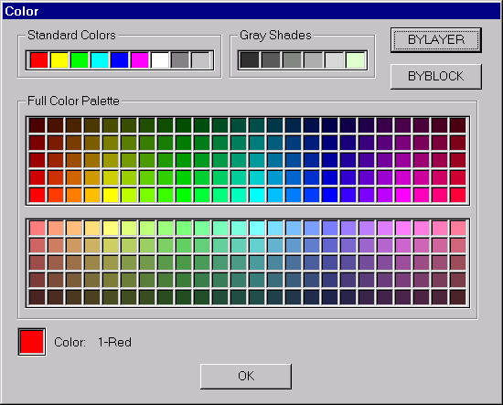

MENU: “Color”
CMDLINE: “TestColor”

Designed to show how to get AutoCAD color indexes to come out correctly in an MFC dialog

MENU: “Purge”
CMDLINE: “TestPurge”

Doesn’t actually purge anything. Lets you select various entities and objects and then prints out which ones are purgable and which ones are not (according to the AcDbDatabase::purge()) function.

MENU: “Count References”
CMDLINE: “TestCountHardRefs”

Calls the AcDbDatabase::countHardReferences() function and reports the results.

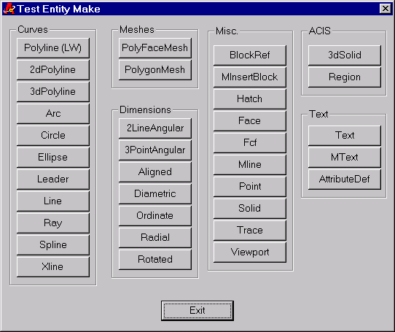
MENU: “Making Entities”
CMDLINE: “TestEntMake”

This command is intended as sample code for developers on how to make all the built-in entity types.

NOTE: This has not been updated since R14, so it may have some omissions or bugs. It also showed a more straight-forward method for making objects in different UCS’s, although it doesn’t seem to work for some entities, like AcDbHatch.

MENU: “Making Symbol Tables”
CMDLINE: “TestTblMake”

Similar to the one above, except that it deals with Symbol Tables.
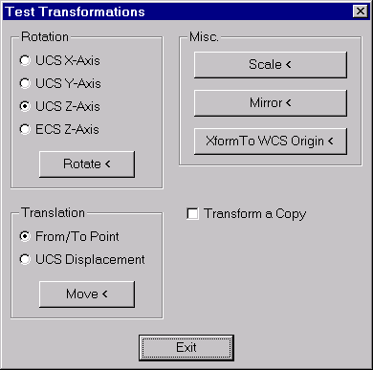
MENU: “Transform By”
CMDLINE: “TestXform”

Intended as sample code for developers to see how to do the various transformations.

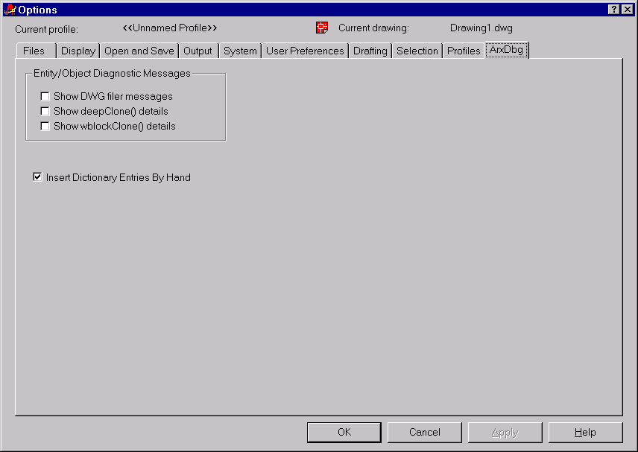
There is a page added to the regular AutoCAD options dialog for a few ArxDbg toggles. This also serves as an example to developers as to how to add to the Options dialog.

Show DWG filer messages:
For any object derived from ArxDbgDbDictRecord or ArxDbgDbEntity, it will print out what type of DwgFiler is being used during all the calls to dwgInFields() and dwgOutFields(). This is sometimes useful just to get an idea of the sequence of events and in which context certain filers are used.

Show deepClone() details:
For any object derived from ArxDbgDbDictRecord or ArxDbgEntity, it will print out the IdMap at the beginning and end of this call.

Show wblockClone() details:
For any object derived from ArxDbgDbDictRecord or ArxDbgEntity, it will print out the IdMap at the beginning and end of this call.

Insert Dictionary Entries By Hand:
Turning this off will demonstrate how Dictionary records are orphaned without all the extra help from the routines in the Editor Reactor.

The Sample Entities:

There are a few sample entities/objects included in ArxDbg that are designed to test some of the common things done in AEC objects.

ArxDbgDbDictRecord
Base class for dictionary resident objects. This is used to account for all trans-database operations that would otherwise orphan dictionary records. All classes that derive from this will get Insert/Wblock/Xref-Insert/Xref-Bind/wblockCloneObjects() behavior for free. There is also code in the class ArxDbgAppEditorReactor to help with the cloning process during an Insert.

ArxDbgDbAdeskLogoStyle
Derived from ArxDbgDbDictRecord. Has some information that the ArxDbgDbAdeskLogo object uses.

ArxDbgDbEntity
Base class for all entities. Has some basic MOVE/ROTATE type functionality, plus a generic implementation of deepClone() and wblockClone() that all derived classes can use to automatically handle inter-object relationships.

ArxDbgDbAdeskLogo
Derived from ArxDbgDbEntity. Has the two basic properties that AEC objects have.

A HardPointerId to a “style” object (dictionary resident)
A Hard or Soft reference to another entity.

This is in here to show how to correctly deal with deepClone and wblockClone for these types of relationships. When asked for the entity to select for the arbitrary reference, it will figure out a good attachment point for LINE, ARC, CIRCLE, POINT, and BLOCKREF. For any other entity, it uses the values returned from AcDbEntity::getEcs() (which for many AutoCAD entities is the WCS origin, so be careful about which types of entities you pick).

